**EXPERIMENT NO. 8**

**TO PERFORM BASIC BINARY CLASSIFICATION OF ANY DATA OR PATTERN USING NAÏVE BAYES CLASSIFIER.**

**EXPERIMENT NO. 8: Classification**

**AIM: -** To perform basic binary classification of any data or pattern using Naive Bayes Classifier.

**OBJECTIVES:**

1. To use and understand dataset.
2. To extract classify data.
3. To calculate accuracy of the classifier.

**EQUIPMENTS/SOFTWARE:** Python

**THEORY: -**

A classifier is a machine learning model that is used to discriminate different objects based on certain features.

A Naive Bayes classifier is a probabilistic machine learning model that’s used for classification task. The crux of the classifier is based on the Bayes theorem.

Bayes Theorem:

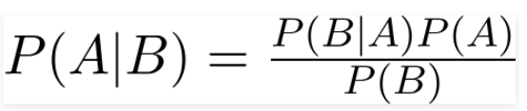

Using Bayes theorem, we can find the probability of A happening, given that B has occurred. Here, B is the evidence and A is the hypothesis. The assumption made here is that the predictors/features are independent.

Naive Bayes algorithms are mostly used in sentiment analysis, spam filtering, recommendation systems etc. They are fast and easy to implement but their biggest disadvantage is that the requirement of predictors to be independent.

**CONCLUSION** :-

**Code:-**

**Output:-**